IDE Used

IDE: CLion

IDE Version: 2021.2.1

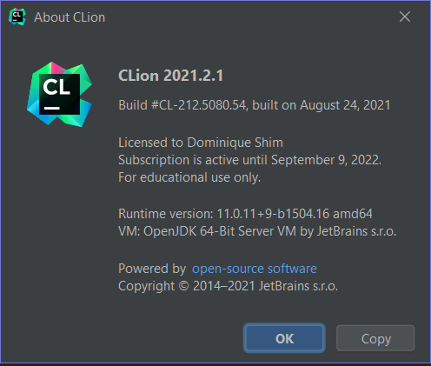

**Environment**

Environment for IDE: MinGW

Compile: G++

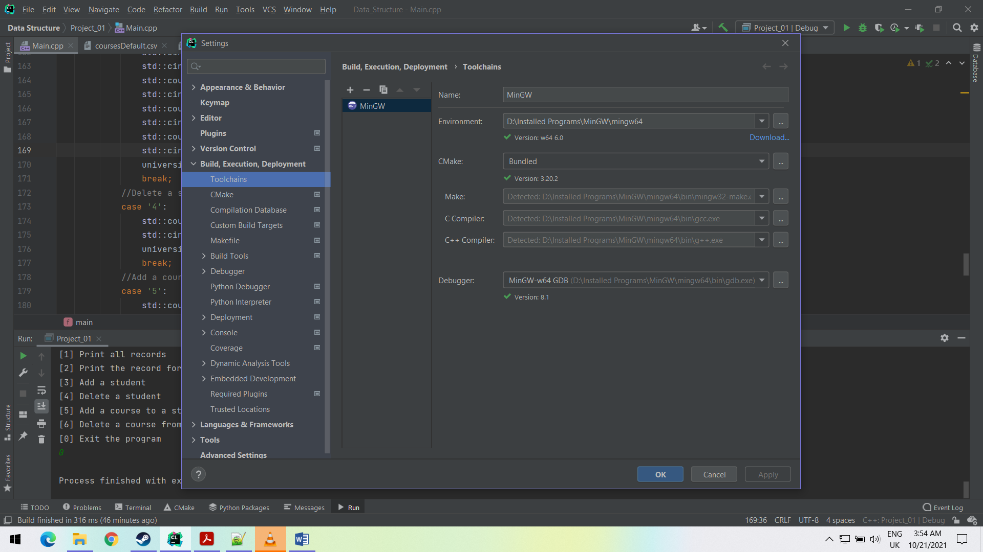

**File Directory**

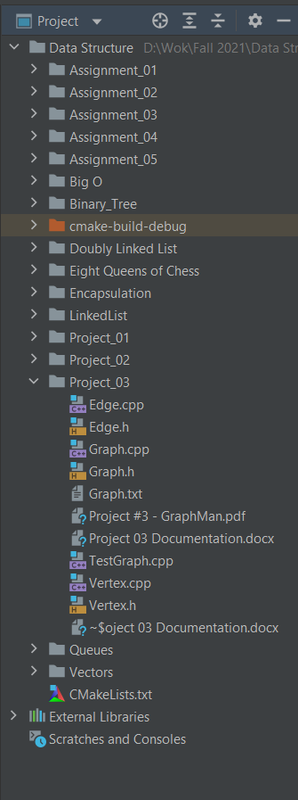

**Testing**

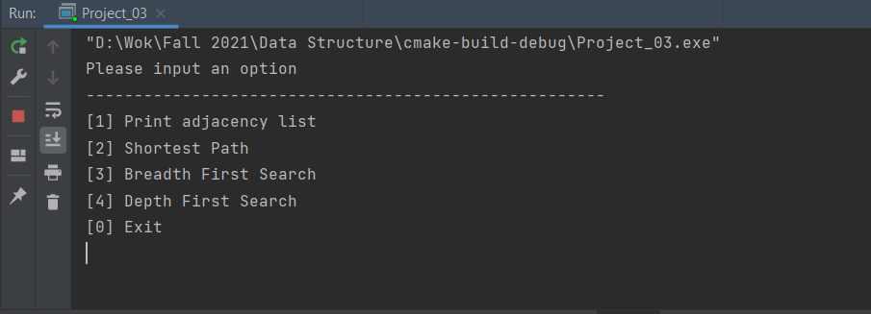

Startup showing the UI and the options that the user has

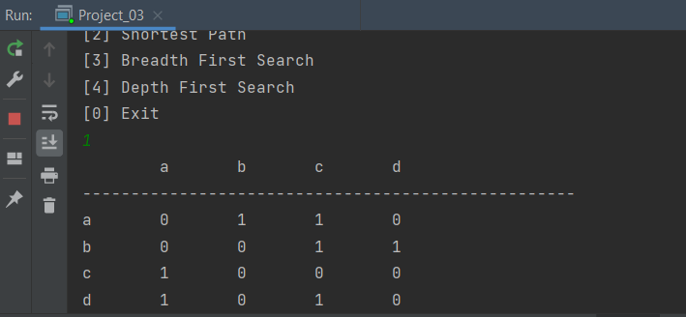

Performing the adjacency list.

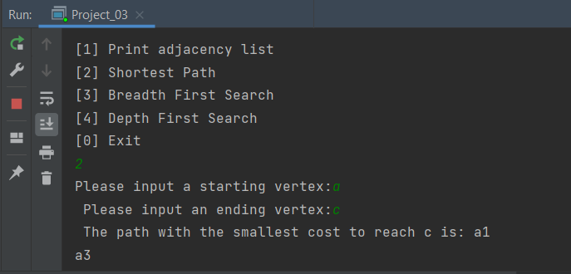

The program finding the shortest route from node a to node c, displaying the best path.

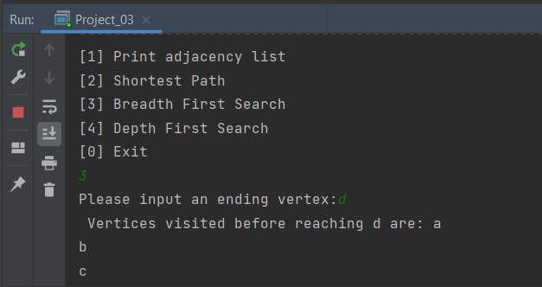

Performing a breadth first search.

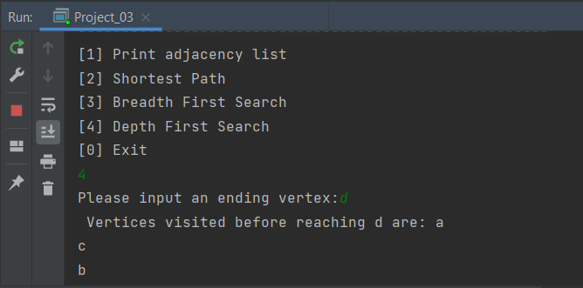

Performing a Depth First Search.